12.19: 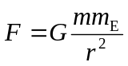
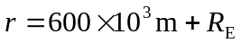 so 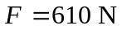

At the surface of the earth, 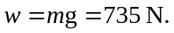

The gravity force is not zero in orbit. The satellite and the astronaut have the same acceleration so the astronaut’s apparent weight is zero.

